**DFLOW**

**DFLOW_BRD_V1.0_20222004**

***Creation Date***

***20/04/2022***

**Table of History**

| NOTES | UPDATE DATE | UPDATED BY | UPDATES DESCRIBTION | VERSION NO. |
| --- | --- | --- | --- | --- |
|  | Created 24/04/2022 | Nora Alsubaie |  | V1.0 |
|  |  |  |  |  |
|  |  |  |  |  |

**Project Details**

|  | Project Name |
| --- | --- |
| Data gathering and data intelligence | **Project Type** |
|  | **Project Start Date** |
|  | **Project End Date** |
|  | **Primary Driver** |

**Document Resources**

| Role | Business Unit | Name |
| --- | --- | --- |
|  |  |  |
|  |  |  |

**Definitions & Abbreviation**

| Stands for | Abbreviation/ Terms |
| --- | --- |
| The end customer who has subscribed to Dflow. | **Client** |
| Who is responsible for updating influencers advertising activities as a record. | **Researcher** |
| who has CRUD for all system functions | **Admin** |
| A List of influencers that assigned to a researcher. | **Influencers Group** |
| The fields of input | **Field** |
| The full row of fields that had been filled by Dflow researcher | **Record** |
| A well designed PPtx and PDF file | **Exported Report** |
| Where is a company that has record on the same category that the client has selected.  It considered a competitor when it has more than 15 ads in last 30 days | **Competitor** |
| Other type of record | **Trending** |
| list of influencers that result based on criteria defined by the user | **Influencers Allocation** |
| Referenced to field Company that is inside the Record table | **Brand** |

**Introduction**

1. **Purpose**

The goal is to create a system that enable DFlow team to analyze influencers activities smoothly and effectively. And to help influencers management team to select, archive and schedule influencers campaign via Dflow Planner. And to measure influencers engagement rate via links tracker. The system has to be versatile to the expanding service scope and highly secure due to the nature of the information in it.

1. **Scope**
2. Well designed website, that let user to explore DFlow services and can submit a demo request. (Done)
3. A system that has the following functionality ( Login for all types of users, CRUD [users, records elements], Export [Reports, Influencers Allocation], Dashboard, Influencers database, upload, View download and share video. (Partially Done)
4. Dashboard that provides the following analysis: based on range of date, company name، industry

1- Competitors campaign estimated cost.

2- Influencers Advertising Intensity during a range of date.

3- Competitors Offers & Promoted products.

4- Competitors Target Market.

5- Influencers Trending Topics.

6- Influencers Insights per brand or industry.

1. Influencers Database & insights.
2. DFlow Planner ( Influencers Allocation Linkable&trackable, Campaign Calendar )
3. Customized Field
4. Payment gateway. (Later)
5. OTP Auth (Email)
6. Scheduled report (Later)
7. Links Tracker.

**Stakeholders:**

1. Researcher
2. Influencers Management Department (IMD).
3. Business Development.
4. Admin
5. SI client

**Data Stream:**

1. Manually tracked platforms (Active)
2. SI Systems. (Later)
3. Platforms APIs integrations.(Later)
4. **Overview**
5. **Assumptions, Dependencies, and, requirements**

The system will be web-based; and mobile friendly,also, it is a big data center take care of server stability. To avoid losing data the system requires to do a daily backup automatically.

each user can login from one IP address, meaning it is not allowed to have two IP addresses for one user at the same time.

1. **Entities Fields:**

| **Client** | **Company name, company logo, website, contact email, contact person name, company size, company industry, primary categories,** |
| --- | --- |
| **Influencers** | **Name, IMG(hidden for now.March2022), gender,, country, city, content category (primary+secondary "could be between 1-3") Platform name(multiple), platform handler, platform service (Multiple) ad price per service at a platform, size per platform, Followers (Optional)**  **Date of Birth (Optional)**  **Insights per platform Audience Info: Optional**  **Geo->**  **Country or city1 , rate or number**  **Country or city 2 , rate or number**  **Country or city 3 , rate or number**  **Interest->**  **Name1 , rate**  **Name2, rate**  **Name3, rate**  **Gender->**  **Percentage of Female audience**  **Percentage of Male audience** |
| **Platform** | **Name, Service(Multiable), Icon.** |
| **Company (one of the record field)** | **Name AR EN, Logo(Optional), Link, industry(Optional)** |
| **Researcher** | **Name, Email ،influencers group** |
| **Influencers Group** | **influencer name, platform name, platform handler, assigned researcher)** |
| **Content Record** | **Influencer name, Video clip, date, platform, Company name** |
| **Calendar** | **Date, Influencer Name(Dropdown List), Campaign Name, description.** |
| **Link Tracker** | **Influencer name,Destination Link, (all insights that we can get from link tracker)** |
| **Ad record** | **Date (Calendar)**  **Influencer Name (Drop-down list source “Influencers Database”).**  **Company (Drop-down list).**  **Platform (Check Box)**  **Promoted Products ( Text ) Optional**  **Category (Multiple Selections)**  **Gov. Ad (Boolean)**  **Mention “AD” word? (Boolean)**  **Promotion Type (Multiple Selections)**  **Ad Type (Drop-down list)**  **Researcher Name (Will be filled automatically by the user name ).**  **Promoted Discount (Dropdown list with in an Other option (text) ) Optional**  **Upload File (Image or Video format name “ Company name , Influencer name , date” ) Optional** |
| **Requirement** |  |

1. **Specific Requirement**
   1. **Requirements BacklogFunctional Requirement**
   2. **Admin**

| E1 | **ID** |
| --- | --- |
| CRUD & Export | **Name** |
| As an admin I can CRUD [users, records elements], Export [Reports, Influencers Allocation], Dashboard, Influencers database, upload, View download and share video. | **Description** |
| * Admin | **Actor(s)** |
| * As an admin, I want to export a report in PTTx format of a client dashboard. * As an IMD member, I want to export Influencers Allocation PTTx format or CSV format. So I can download it and share it with my client. * As an admin, I want to create new platform or new ad type per platform so, when I add new influencer name I can set his price based on the ad type. * As an admin, I want to create new platform or new service per platform, so when the researcher add new record he/she will be able to select which platform and which ad type that the record is belong to. * As an admin or IMD member, I want to be able to share Influencers Allocation link and the link is trackable ( number of shares, number of views ) and make the link valid for limited of time. So I can share the link to an outside Dflow member. * As an IMD member, I want to share a video to an outside Dflow member. | **Process** |
|  | **Output** |
| 1. CRUD users. ( The current version let create new user role ) 2. CRUD records elements. ( The current version let admin update records elements) 3. Export Reports. ( There is export option but it does not work , also, it support excel and PDF only). 4. CRUD Influencers Database ( The current version does not allowed to add new platform account to an influencer, also, it does not have the Ad Type per platform). See details in Entity Fields page. 5. Upload, View download and, share video. (the upload video) | **Status of Delivery** |

* 1. **Competitor Discovery**

| 2.1 | **ID** |
| --- | --- |
| Competitor Discovery -> Market overview | **Name** |
| As a user I can navigate competitor discovery tab then Market overview tab to view analysis based on Indusrty. | **Description** |
| * Admin * Client * Business Development | **Actor(s)** |
| * A user navigate to the tab * Choose a parent category * Select date range * View the following analysis:  1- Total Number of brands that have ads records in this category or on one or more of the child categories.   2- Total Number Ads thas have been captured in this category or on one or more of the child categories.  3- Number of unique influencers that have been performing ads in this category or on one or more of the child categories.  4- Density chart that shows the density of ads per weeks/months  5- Top brands  6- Top Influencers | **Process** |
| * View Analysis based on indusrty. | **Output** |
|  | **Business rules and Constraints** |

| 2.2 | **ID** |
| --- | --- |
| Competitor Discovery -> Competitive Analysis | **Name** |
| As a user I can navigate competitor discovery tab then Competitve Analysis tab to view analysis based on brands. | **Description** |
| * Admin * Client * Business Development | **Actor(s)** |
| * A user navigate to the tab * Select Date range. [ 30days ago by default]. * View list of competitors * Select one competitor or search by brand name. [the search results are limited to the client industry]. * View the following analysis:   1- Brand Name  2- link to Show all details  3- Campaign Estimated cost  4- Number of Total Ads  5- Number of unique influencers  6- A Cloud Words chart shows Promoted Discounts  7- A Cloud Words chart shows Promoted Products  8- A Pie chart shows the AD type  9- A Bar chat shows the Promotion Type  10- A Density chart shows the rush days  11- top 3 of most influencers used  12- A donut chart of influencers size  13- A donut chart of Influencers Gender  14-A Horizontal bar chart that shows types of influencers content | **Process** |
| * View Analysis based on brand | **Output** |
| Analysis based on Company name. The current version does not allow user to search for company name to see its analysis.  Analysis based on Industry. (The current version does not allow the user to view analysis based on industry).  Competitors Promoted products. ( The current version does not show companies’ promoted products )  Competitors campaign estimated cost. (Need to recheck since the current version does not support adding influencer price )  Client Dashboard that provides analysis based on range of date. (Done)  Influencers Advertising Intensity during a range of date. (Done)  Competitors Discounts. (Done) | **Status of Delivery** |

| 2.2.1 | **ID** |
| --- | --- |
| View all details | **Name** |
| As a user, I can click on Show all details this will take me to Explore Ads tab - > then will view a table of that brand’s ads details | **Description** |
| * Admin * Client * Business Development | **Actor(s)** |
| * The user will click on Show all details | **Process** |
| * Ads info table of that brand will displayed successfully | **Output** |
|  | **Business rules and Constraints** |

| 2.2.2 | **ID** |
| --- | --- |
| View list of influencers. | **Name** |
| As a user, I can click on View all that is linked to the Number of Unique influencers metric. | **Description** |
| * Admin * Client * Business Development | **Actor(s)** |
| * The user will click on View all that is linked to the Number of Unique influencers metric. | **Process** |
| * List of influencers with the following details will be displayed. Influencer name, platforms handler, size, gender, counrty, category. | **Output** |
|  | **Business rules and Constraints** |

* 1. **DFlow Planner**

| 3.1.1 | **ID** |
| --- | --- |
| Discover Influencers | **Name** |
| Influencers Database. | **Description** |
| * Admin * Client * IMD | **Actor(s)** |
| * The user can navigate to DFlow Planner tabe -> Discover influencers * The user can select one of the influencer that is showen on the table or search by Influencer Name, Content Category, or, Country. | **Process** |
| * List of influencers are displayed successfully, each influencer name is clickable | **Output** |
| The Client search inputs most be stored and be accessible to the Admin | **Business rules and Constraints** |

| 3.1.2 | **ID** |
| --- | --- |
| Discover an Influencer | **Name** |
| Influencers Insights, This feature let users discover insights on an influencer ads activities, such as latest ads, ads category, number of most repeated brands, influencers rush days | **Description** |
| * Admin * Client * IMD | **Actor(s)** |
| * The user can click on the influencer name. * This will take him to the influencer page * The user is able to see the following info:   1- influencer image if available.  2- Platforms info (Platform icon, Social Media account, Number of Followers, Content category.   * The user is able to select date range to see ads insights. the default date range is 30 days ago. * Influencers Insights:   1- Number of Captured Ads.  2- A Pie charts of Ads category.  3- A table of most repeated brands along with the total number of ads  4- An ads peak days chart. | **Process** |
| * a table of latest ads will showup successfully. * insights based on date range will display successfully. | **Output** |
| The Client search inputs must be stored and be accessible to the Admin | **Business rules and Constraints** |

| 3.1.2 | **ID** |
| --- | --- |
| On selcet influencers, three buttons will show up | **Name** |
| the suer can select and create link tracker | **Description** |
| * Admin * Client * IMD | **Actor(s)** |
| * On select one or more influencers from Discover influencer page. * A three buttons will showup   1- Add to my calendar.  2- Create Link tracker.  3- Export influencers Allocation - > this will appear to Admin and IMD only | **Process** |
|  | **Output** |
|  | **Business rules and Constraints** |

| 3.1.3 | **ID** |
| --- | --- |
| Create link tracker Influencers | **Name** |
| the suer can select and create link tracker | **Description** |
| * Admin * Client * IMD | **Actor(s)** |
| * The user can select 1 or more influencers from Discover influencer page. * A create link tracker button will showup * The user will click on this button * The user will enter a Destination link * The user will selcet if he wants to apply the same destination link to all selected influencers or he can enter a destination link for each influencer. | **Process** |
| * a link tracker will be created for each influencer * a success message will show up to the user | **Output** |
|  | **Business rules and Constraints** |

| 3.1.4 | **ID** |
| --- | --- |
| Add to my calendar | **Name** |
| The user can select influencer | **Description** |
| * Admin * Client * IMD | **Actor(s)** |
| * The user can select 1 or more influencers from Discover influencers page. * Add to my Calendar button will showup * The user will click on this button * The user will select previous campaign name or he will enter a new campaign name * The user will save changes | **Process** |
| * a new event will be created on the calendar * a success message will show up to the user * The event will be shown on the user account only. * Admin and IMD has a shared calendar | **Output** |
|  | **Business rules and Constraints** |
|  | **Estimated Time** |

* 1. **Requests management**
  2. **Department management**
  3. **Roles & permission management**

|  | **Researcher** | **IMD** | **Client** | **Admin** |
| --- | --- | --- | --- | --- |
| Create new user | **x** | **x** | **x** | **√** |
| View all users | **x** | **x** | **x** | **√** |
| Export Report Dashboard screen | **x** | **x** | **x** | **√** |
| Export Influencers Allocation | **x** | **√** | **x** | **√** |
|  |  |  |  |  |
| Veiw companies list | **√** | **√** | **x** | **√** |
| Create company | **√** | **√** | **x** | **√** |
| Create influencers | **x** | **√** | **x** | **√** |
| View influencers | **√** | **√** | **√** | **√** |
| Records |  |  |  |  |
| View Created_by | **x** | **x** | **x** | **√** |
| View Ad records (Explore Ads) | **√** | **√** | **√** | **√** |
| Edit, delete, update record | **x** | **x** | **x** | **√** |
| Update my own record | **√** | **x** | **x** | **√** |
| Add new record | **√** | **x** | **x** | **√** |
| View archive | **x** | **√** | **x** | **√** |
| Create, update,delete platform, category, service per platform, ad type,promotion type. | **x** | **x** | **x** | **√** |
|  |  |  |  |  |

Wireframe:

Market Overview 2.1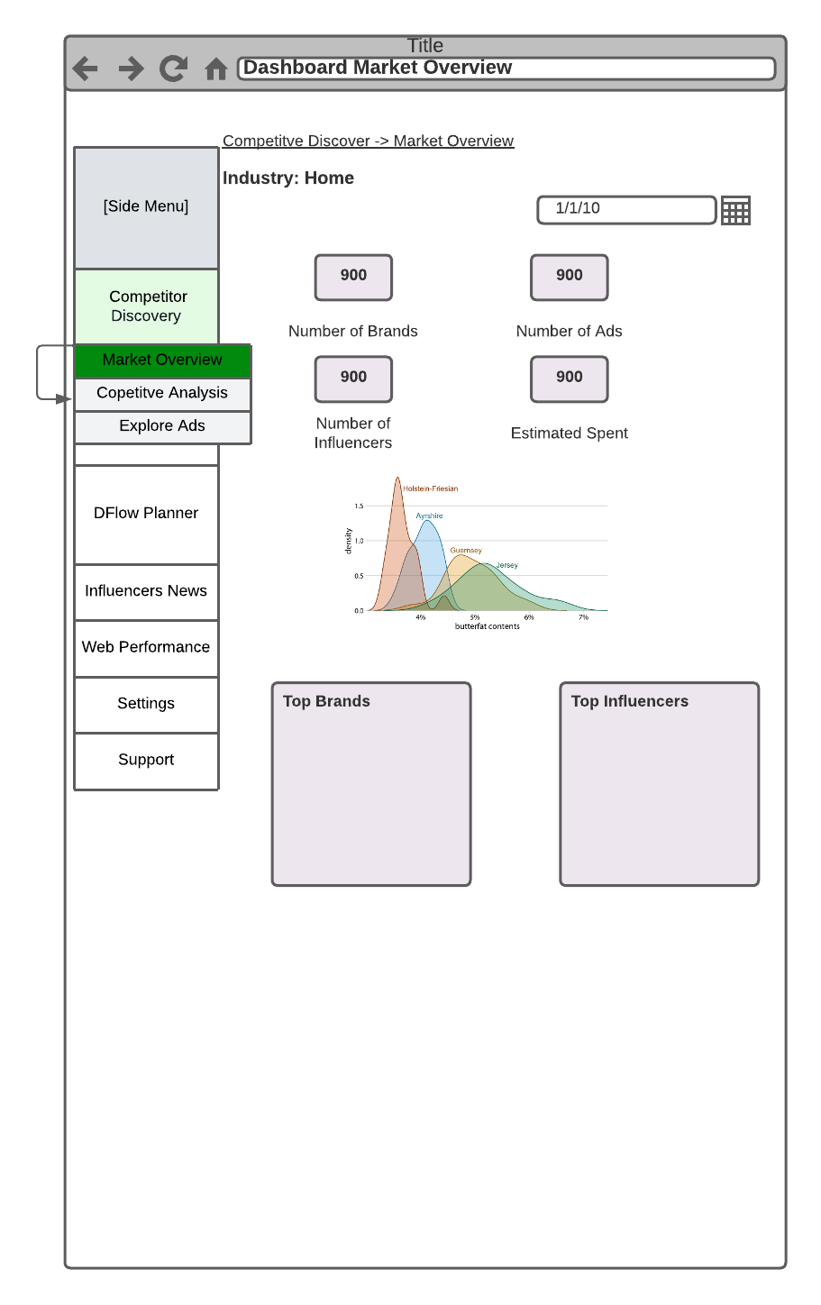

Competitve Analysis 2.2

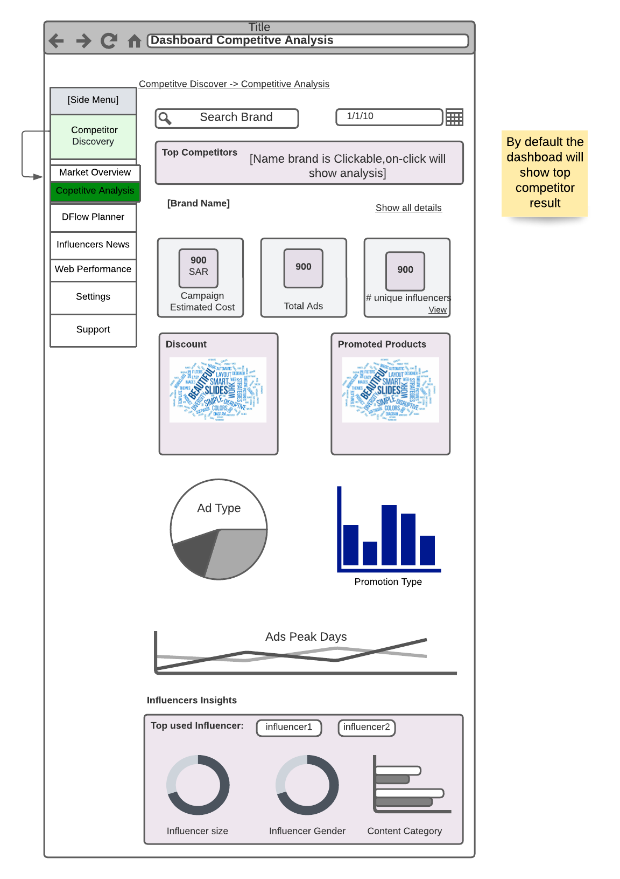

Discover Influencers 3.1.1

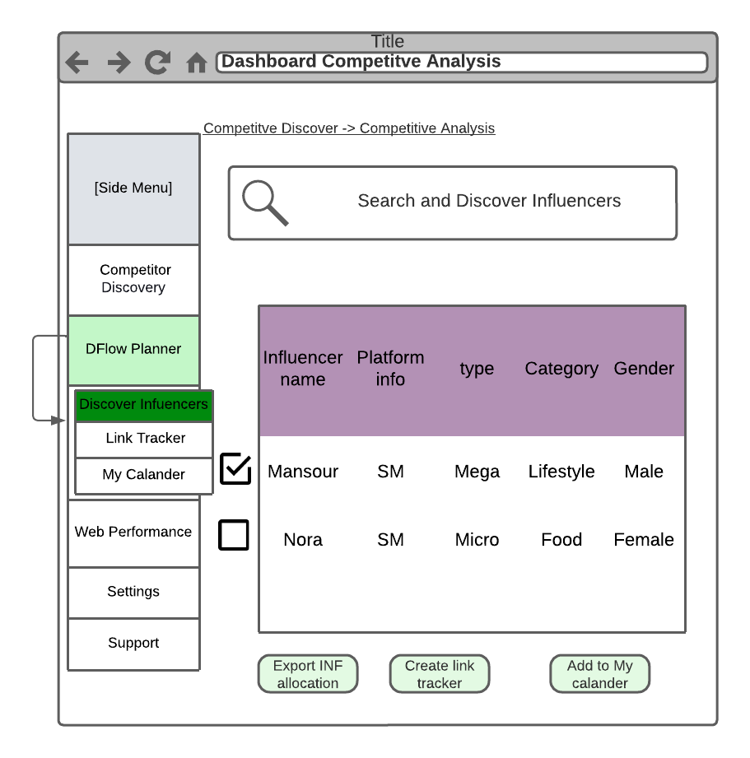

Discover an influencer 3.1.2

